SOL DESIGN

Problem Description:

The current design of SOL (Serial Over Lan) application obmc-console server and client supports only a single host. It handles only single console. Current implementation may not supporting multi host or multiple console as it creates a single socket to connect server and server also opens only one tty device.

Proposed Design:

The Goal of this design document is to support multiple console’s in obmc-console applications
So, we propose following design/implementations to support multiple hosts.

- We will create a config file with the details of all the host in obmc-console.conf. This will have the information of serial console device nodes and the baud-rate.

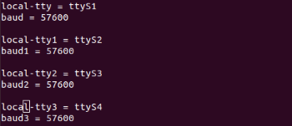

- The obmc-console@.service will be created to read this config file and spawn one instance of obmc-console-server application per host.

- Obmc-console-server application will get the device file and baud-rate as parameters

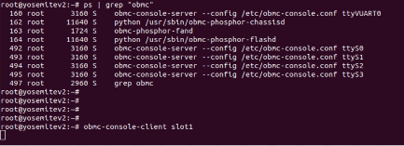

- Obmc-console-server will be modified to create socket fd in the path "\0obmc-console-1" for ttyS1, "\0obmc-console-2"for ttyS2, and so on. We will make it as an array to store all the paths.
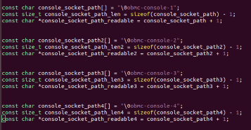

- Obmc-console-server will be modified to bind the socket based on the tty device files.

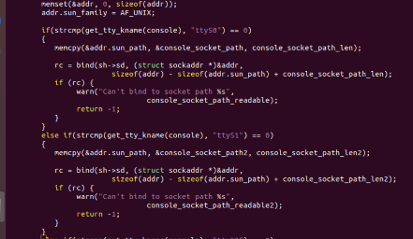
- Obmc-client needs to be updated as to get slot id as an input parameter.
- Obmc-clent will be modified to connect with the respective socket id created for the particular host slot-id, so it can get connected to the socket and console messages can be displayed.

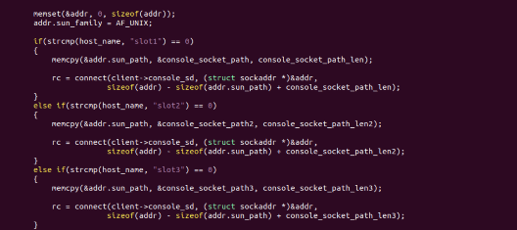

Design Impact:

This design will support multi host console. Also, it should not affect the single host design/console. So, we will use multihost=yes in the config file and based on this flag, will implement multi host support code changes in obmc-console applications.

