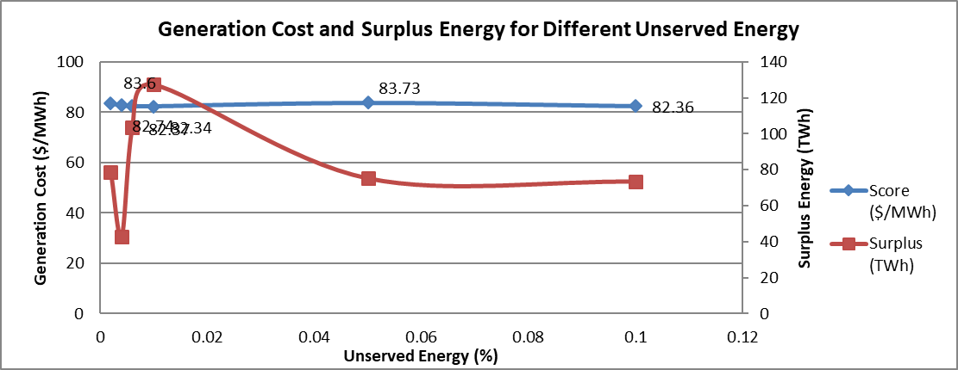
Figure 1. Cost and Surplus for different unserved energy constraints

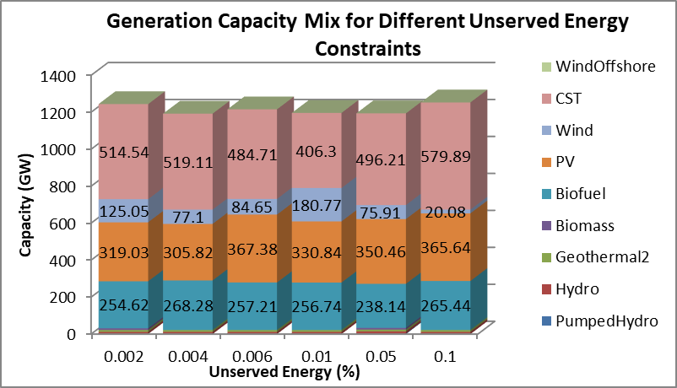
Figure 2. Generation capacity mix for different unserved energy constraints

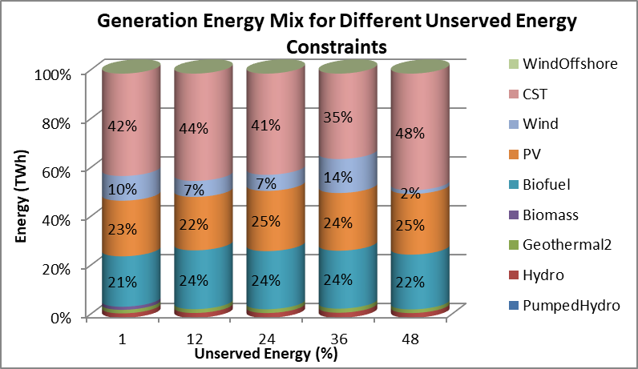
Figure 3. Generation energy mix for different unserved energy constraints

